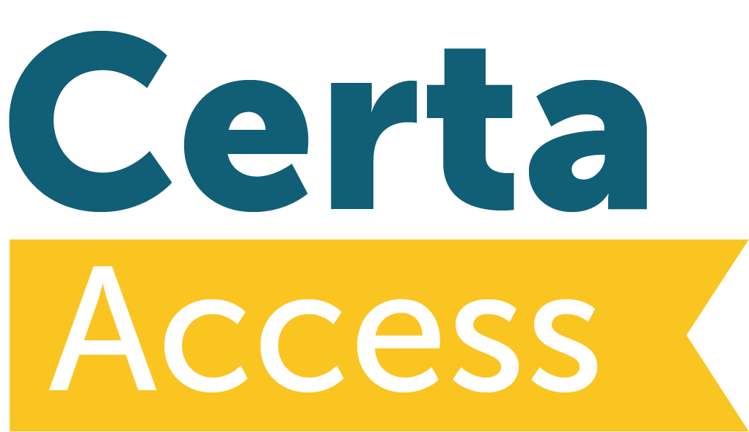


Application for an Aegrotat Award

An Aegrotat Award of the Access to HE Diploma may be awarded to a student who has fulfilled some of the requirements for the Award, but was prevented, by exceptional, extenuating, certificated, medical circumstances from achieving the requisite 60 credits (including, at least, 45 at level three).

The AVA expects that such circumstances did not exist at the time of enrolment of the student.

This form must be completed by a provider for any student for whom an Aegrotat Award is being requested.

Before submitting a request for an aegrotat award, the student must be confident that they can complete successfully in HE and will have demonstrated they have contacted their receiving HEI/s for confirmation of an aegrotat award as an appropriate award for progression. The provider must be able to support the student request for an aegrotat.

The student must have achieved at least 30 credits of the 60 credits required.

This request must be authorised by the provider’s Quality Manager/Head of Teaching & Learning or other senior person, who must sign the completed request prior to submission to Certa.

If the application is approved, the certificate awarded will state that it is an Aegrotat Award.

This form must be fully completed and arrive at Certa, at least, two weeks prior to the date of the final Awards Board. The details of the application will not be discussed at the Awards Board.

An Aegrotat Award is not guaranteed.

The external moderator and the Awards Board must approve the Award of the Aegrotat. The AVA’s Access to HE Committee must also ratify the decision.

The Access to HE Diploma is awarded without full credits; the unit and grade profile will be incomplete. The Diploma awarded will state that it is an Aegrotat Award.

Application for an Aegrotat Award
Application Form

Provider Name:
Provider Site/Campus:
Access to HE Diploma Title:
Student Name:
Run ID:
Details of person making this request on behalf of the student:

Name:

Email Address:

Role:

Telephone Number:

Unit Achievement: please list below the details of the units for which the student will be recommended for the award of credit this academic year.

Unit Title | Certa  Unit Code | Graded/  Ungraded | Credit Value | Credit Level

Non-Achievement: please list below details of units which the student has not achieved.

Unit Title | Certa  Unit Code | Graded/  Ungraded | Credit Value | Credit Level

Non-Achievement: Please describe evidence of partial achievement available for each of the non-completed units.
Unit Title | Certa  Unit Code | Evidence

Total Credits to be Recommended at Level 2:

Total Credits to be Recommended at Level 3:

Total Credits Recommended (must be at least 30 credits):

Extenuating Circumstances:

Please describe fully the exceptional extenuating, medical circumstances on which the claim for the award is based, including dates and timescales. Ensure that a full explanation of exactly how these circumstances have affected the student’s achievement is included.

Supporting Evidence:

Please indicate what supporting evidence is available to support this claim (eg medical certificate). The external moderator must verify sight of this evidence at the final Awards Board.

Provider Statement:

Please explain why the provider considers that an Aegrotat Award would be in the best interest of this student.

Process and Involvement:
Please describe the process followed internally and state who has been involved in reaching the decision to request an Aegrotat Award for this student.

Confirmation of Student
(An actual signature must be appended and not just a change of font).

The implications of being awarded an Aegrotat Award have been fully explained to me including the possibility that it may not be accepted by a Higher Education institution as evidence that an offer of a place has been achieved.

Signature:
Date:

Authorisation Statement of Provider’s senior member of staff:

I confirm that this request has been through a robust internal process as outlined above and the request is considered to be in the best interests of the student. The student is fully aware of any implications of the receipt of an Aegrotat Award.

Signature:
Date:

Please forward this fully completed document, with appropriate supporting evidence to: AVA Team, Certa, Certa House, Lower Warrengate, Wakefield, West Yorkshire WF1 1SA or by email to accesstohe@certa.org.uk.

The documentation will then be forwarded to the External Moderator and the Head of Access to HE for consideration. Decisions will normally be communicated to the centre within five days of receipt of the documentation by Certa.

After the Awards Board, if required, the AVA will submit the Awards Board’s recommendation for the award of an Aegrotat Diploma to the Access to HE Committee for ratification.

