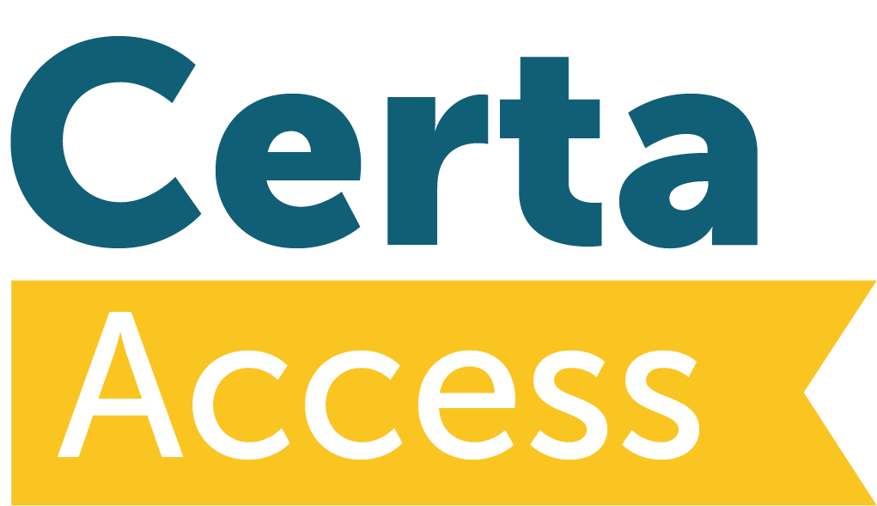


Notification by Provider of:
Closure of Diploma, Suspension of Diploma, Non-running of Diploma

This form must be completed by the provider and returned to Certa to enable the AVA to take appropriate action. One form to be completed for each named Diploma.

Name of Provider:

Title of Diploma:

Name of Diploma Contact:

Email Address of Diploma Contact:

Name of Quality Contact:

Email Address of Quality Contact:

Site(s) at which the Diploma is run:

Last Date of Registration of Students:

End Date of Diploma:

Please indicate whether this is a permanent closure of the Diploma; temporary non-running of the Diploma for the academic year (possibly due to insufficient student numbers) or transfer to another AVA:
If this is a temporary non-running of the Diploma due to insufficient student numbers, please indicate what future marketing plans are in hand to promote the Diploma:

If this is a transfer to another AVA please say which AVA the Diploma is being transferred and the reasons for such transfer:

If any students are involved in a transfer of business please indicate the numbers and what arrangements have been made for the students:

Please confirm that the arrangements indicated above have been approved by the Senior Management Team and indicate the name of the SMT member:

Signed by:
Name:
Role within organisation:
Date:

For Use by Certa
(1)
Date received:

Indicate what correspondence/meetings/negotiations etc have taken place and with whom:

Indicate any financial implications:

Access to HE Manager to sign to confirm that closure procedures can be processed:
Signature:
Date:

Date letter sent in confirmation to the provider:

(2)
Date details passed to Access to HE Committee and by whom:
Signature:
Date:

(3)
QAA Database updated by:
Signature: Date:
Quartz updated:
Signature: Date:
Other SEG personnel advised:

