 |  | Researching and Understanding Opportunities in Higher Education: Assignment 2 of 2
Diploma: | Access to HE:
Unit and Code: | Researching and Understanding Opportunities in Higher Education – CER240
Level | 3 |  |  |  | Credit Value |  | 3
Academic Year:
Date  Set: |  |  | Draft Deadline  (if appropriate) |  |  | Deadline Date
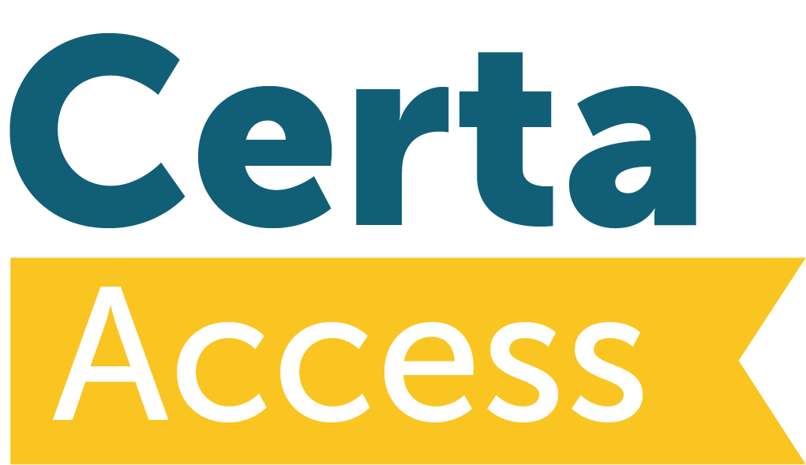
Assignment Title: | Personal Statement and Application

LEARNING OUTCOMES | ASSESSMENT CRITERIA
The learner will: | The learner can:
- Understand the importance of broader life experiences and transferable skills in relation to progression to Higher Education. | - Explain the importance of life experiences and transferable skills to Higher Education progression.  - Prepare, review and revise an application for entry into a Higher Education institution.

Type of Assignment, [with formatting]: | Personal statement and copy of HE (or equivalent) application
Word Count: | As appropriate for UCAS or equivalent
Assignment Brief, [and mapping to unit]: | - Draft a |Personal Statement for your HE application, submitting the draft and the final version to the portfolio  - Explain the importance of life experiences and transferable skills to Higher Education progression. [4.1]  - Include a printout of your completed UCAS / HE application (or alternative application / summary if you are not applying to HE this year) [4.2]

